**Product Sales Analysis Project Design and Innovation**

|  |  |
| --- | --- |
| **Date** | **04-10-2023** |
| **Team ID** | **3932** |
| **Project Name** | **Product Sales Analysis using ML** |

**Table of contents:**

|  |  |
| --- | --- |
| **1** | **Introduction** |
| **2** | **Problem statement** |
| **3.** | **Design and Innovation Strategies** |
| **3.1** | **Data Collection and Integration** |
| **3.2** | **Data Preprocess and Feature Engineering** |
| **3.3** | **Algorithm Selection** |
| **3.4** | **Model Training and Tuning** |
| **3.5** | **Ensemble Learning** |
| **3.6** | **Real-time Data Integration** |
| **3.7** | **Explainable AI (XAI)** |
| **3.8** | **Continuous Learning Automation** |
| **3.9** | **Scalability and Cloud Deployment** |
| **3.10** | **Ethical Considerations and Privacy** |
| **3.11** | **User-Friendly Interfaces** |
| **4** | **Conclusion** |

**1. Introduction**

In today's rapidly evolving business landscape, the ability to predict future sales trends and customer behaviours is a strategic imperative for organizations seeking to thrive and stay ahead of the competition. Machine learning has emerged as a powerful tool to harness the vast volumes of data generated by businesses and extract actionable insights. This document presents a comprehensive overview of the design and innovation strategies for developing a machine learning-based system dedicated to product sales analysis.

**2. Problem Statement**

In the modern business landscape, organizations across various industries face a common challenge: the need to anticipate and adapt to shifting consumer preferences and market dynamics. Accurate sales trend prediction and customer behaviour analysis have become mission-critical tasks for companies striving to remain competitive and agile. The problem at hand revolves around leveraging machine learning and innovative methodologies to address this multifaceted challenge effectively.

**3. Design and Innovation Strategies**

**3.1 Data Collection and Integration**

Innovation: Comprehensive Data Sources

Collect data from various sources, including sales records, customer demographics, website analytics, marketing campaigns, and external data like economic indicators or seasonality.

Implement data integration strategies to merge and preprocess data from different sources into a unified dataset.

**3.2 Data Preprocessing and Feature Engineering**

Innovation: Feature Extraction and Transformation Apply advanced feature engineering techniques to create meaningful features, including time-based features, customer segmentation, and behavioural patterns.

Utilize text mining and sentiment analysis on customer reviews and feedback to extract insights.

Experiment with techniques such as Principal Component Analysis (PCA) to reduce dimensionality while preserving information.

**3.3 Algorithm Selection**

Innovation: Advanced Algorithms

Choose appropriate machine learning algorithms for the prediction tasks, such as regression models (e.g., linear regression, gradient boosting), time series forecasting models (e.g., ARIMA, Prophet), or deep learning models (e.g., LSTM, Transformer) depending on the nature of your data and problem.

**3.4. Model Training and Tuning**

Innovation: Hyperparameter Optimization and Transfer Learning

Implement hyperparameter tuning techniques such as grid search or Bayesian optimization to optimize model performance.

Explore transfer learning by fine-tuning pre-trained models (e.g., BERT, GPT) to extract insights from unstructured data like social media text or customer reviews.

**3.5. Ensemble Learning**

Innovation: Model Stacking

Experiment with ensemble learning techniques like model stacking, where multiple models are combined to improve prediction accuracy.

Consider bagging and boosting methods for creating diverse model ensembles.

**3.6. Real-time Data Integration**

Innovation: Stream Processing

Incorporate real-time data streams (e.g., IoT sensor data, clickstream data) into your analysis to make timely predictions.

Implement stream processing technologies (e.g., Apache Kafka, Apache Flink) to handle and analyse data as it arrives.

**3.7. Explainable AI (XAI)**

Innovation: Interpretability

Focus on model interpretability and transparency by using techniques like SHAP values, LIME, or model-specific interpretability tools.

Develop visualization tools to help stakeholders understand how the model makes predictions.

**3.8 Continuous Learning and Automation**

Innovation: Automated Model Retraining

Establish a system for continuous learning where the model is regularly retrained with new data to adapt to changing customer behaviours and market conditions.

Implement automated data pipelines and monitoring systems to ensure data quality and model performance.

**3.9 Scalability and Cloud Deployment**

Innovation: Cloud Technologies Leverage cloud computing platforms (e.g., AWS, Azure, Google Cloud) to scale your infrastructure and handle large volumes of data.

Utilize serverless computing and containerization for resource-efficient and cost-effective deployment.

**3.10 Ethical Considerations and Privacy**

Innovation: Ethical AI

Address ethical considerations, such as data privacy, bias, and fairness, by implementing responsible AI practices. Develop policies and procedures for handling sensitive customer data.

**3.11 User-Friendly Interfaces**

Innovation: Interactive Dashboards

Create user-friendly dashboards and visualization tools that allow business stakeholders to explore sales trends and customer behaviour insights interactively.

**Solution Architecture Diagram**

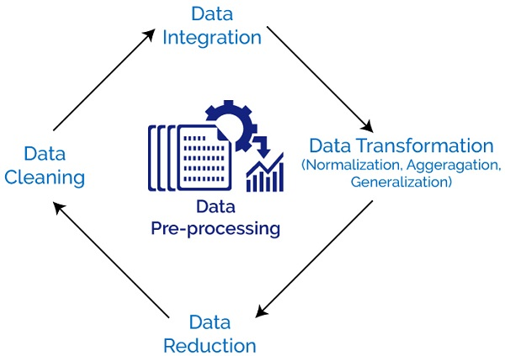

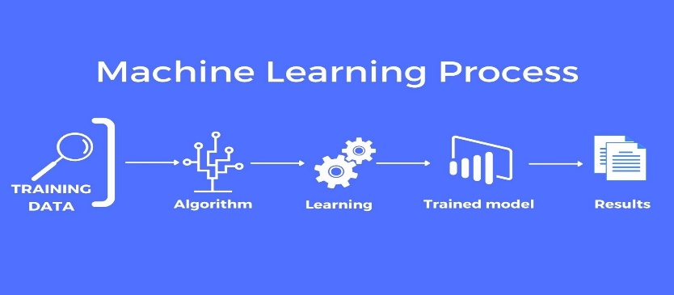

 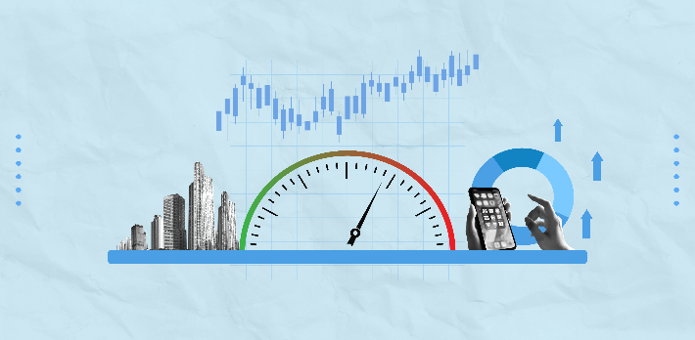

**4. Conclusion**

In the ever-evolving landscape of business, the ability to predict and adapt to changes in sales trends and customer behaviours has become paramount. The strategies outlined in this document, combined with the proposed solution architecture, provide a comprehensive framework for tackling the multifaceted challenge of product sales analysis using machine learning and innovation.

Throughout this document, we have emphasized the importance of innovation at every stage of the process. From the comprehensive gathering of data from diverse sources to the utilization of advanced machine learning algorithms and ethical considerations, innovation serves as the driving force behind our approach.

This implement these strategies and the proposed architecture they position themselves to not only predict sales trends and customer behaviours accurately but also to thrive in an era where innovation and data-driven insights are key drivers of success. By embracing these principles, organizations can harness the full potential of machine learning and innovation to transform their sales analysis processes and achieve sustainable growth.